**Set Tayo Ng Date**

Use Case Specification

Submitted to:

Asst. Prof. Ma. Rowena C. Solamo

Faculty Member

Department of Computer Science

College of Engineering

University of the Philippines, Diliman

Submitted by:

Bandong, Arvin

Bariring, Edward James

Rosales, Kyle

In partial fulfillment of academic requirements

for the course

CS 191 Software Engineering I

of the

1st Semester, AY <2016-2017>

***Unique Reference:***

The documents are stored in the <https://github.com/DarkPotatoKing/cs-191-192-repo>

File reference: <https://github.com/DarkPotatoKing/cs-191-192-repo/tree/master/02-Requirements%20Engineering>

***Document Purpose:***

The purpose of this document is to describe what happens when a user tries to edit an existing or non-existing schedule table of a certain person.

***Target Audience:***

The target audience for this document is the user who wants to edit a certain schedule table.

***Revision Control***

*History Revision:*

|  |  |  |  |
| --- | --- | --- | --- |
| ***Revision Date*** | ***Person Responsible*** | ***Version***  ***Number*** | ***Modification*** |
| 09/29/16 | Arvin Bandong | 1.0 | Initial Document |

*Use-Case Name*: Use-Case 1.2 Edit Schedule

*Description:* The user can edit any available schedule. He can either search the name of the person that he wishes to edit, or manually scan it from the list. After finding the desired schedule table, he can now click “Edit” button and apply the changes he wants to make. After the changes that he made, he can choose to either save or cancel those changes.

*Preconditions:* There should be at least 1 schedule in the database to use Edit.

*Flow of Events:*

|  |  |
| --- | --- |
| ***Scenario Name*** | ***Description*** |
| Scenario 1 (Basic Flow)  User edits a table and saves the changes | 1. User picks a table that he wishes to edit.  2. User scans the list of tables until he finds the one he wishes to edit.  3. User should click the table of that person.  4. User clicks “Edit” button to begin editing.  5. Once editing is done, user clicks “Done” button.  6. A confirmation message will flash.  7. User clicks “Save Changes” button.  8. A message indicating that your changes are saved will be shown. |
| Scenario 2  User edits a table and cancels the changes | 1. User picks a table that he wishes to edit.  2. User scans the list of tables until he finds the one he wishes to edit.  3. User should click the table of that person.  4. User clicks “Edit” button to begin editing.  5. Once editing is done, user clicks “Done” button.  6. A confirmation message will flash.  7. User clicks “Cancel” button.  8. A message indicating that your changes are cancelled will be shown. |
| Scenario 3  User searches for a name and it is not in the database | 1. User picks a table that he wishes to edit.  2. User inputs the name of that person in the search bar.  3. A message indicating that no such name exists will be shown. |
| Scenario 4  User searches for a name that exists and decides to save changes | 1. User picks a table that he wishes to edit.  2. User inputs the name of that person in the search bar.  3. A list of tables that matches with the name being searched will be shown.  4. User should click the table of that specific person.  5. User clicks “Edit” button to begin editing.  6. Once editing is done, user clicks “Done” button.  7. A confirmation message will flash.  9. User clicks “Save Changes” button.  9. A message indicating that your changes are saved will be shown. |
| Scenario 5  User searches for a name that exists and decides to cancel changes | 1. User picks a table that he wishes to edit.  2. User inputs the name of that person in the search bar.  3. A list of tables that matches with the name being searched will be shown.  4. User should click the table of that specific person.  5. User clicks “Edit” button to begin editing.  6. Once editing is done, user clicks “Done” button.  7. A confirmation message will flash.  9. User clicks “Cancel” button.  9. A message indicating that your changes are cancelled will be shown. |

*Activity Diagram of the Flow of Events:*

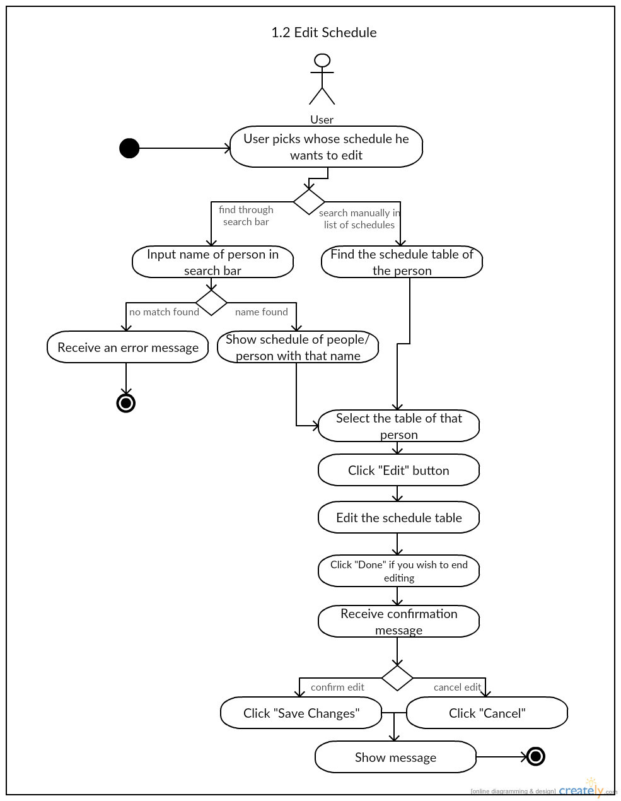

*Postcondition:* NONE

*Relationships:* NONE

*Special Requirements:* NONE